Visualization Tool for Electric Vehicle Charge and Range Analysis

1. **Introduction**

EVs first came into existence in the late 19th century, when electricity was among the preferred methods for motor vehicle propulsion, providing a level of comfort and ease of operation that could not be achieved by the gasoline cars of the time...

**Problem Definition & Design Thinking**

Poor infrastructure is among the most pressing issue among people thinking to opt for electric vehicles. Poor infra doesn't only include a lack of charging stations but also the lack of proper charging set up in their home.

2.1-Empathy Map

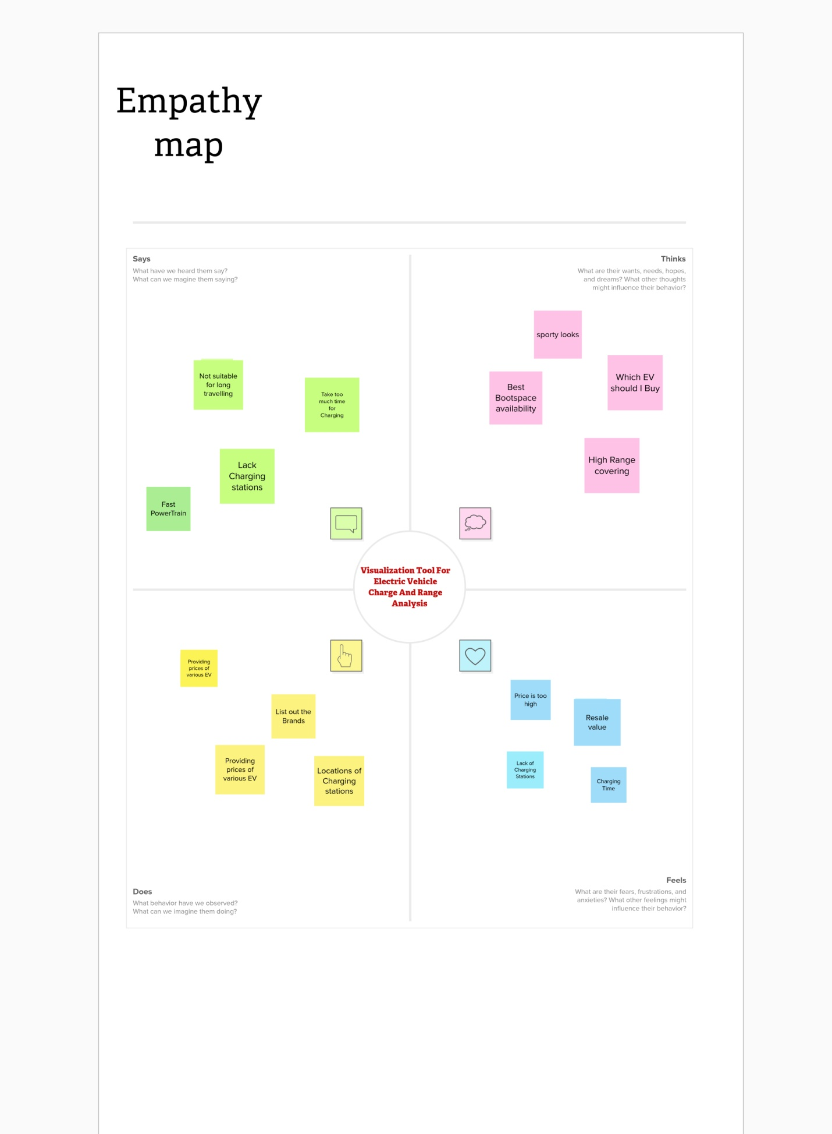

2.2-Ideation & Brain Storming Map

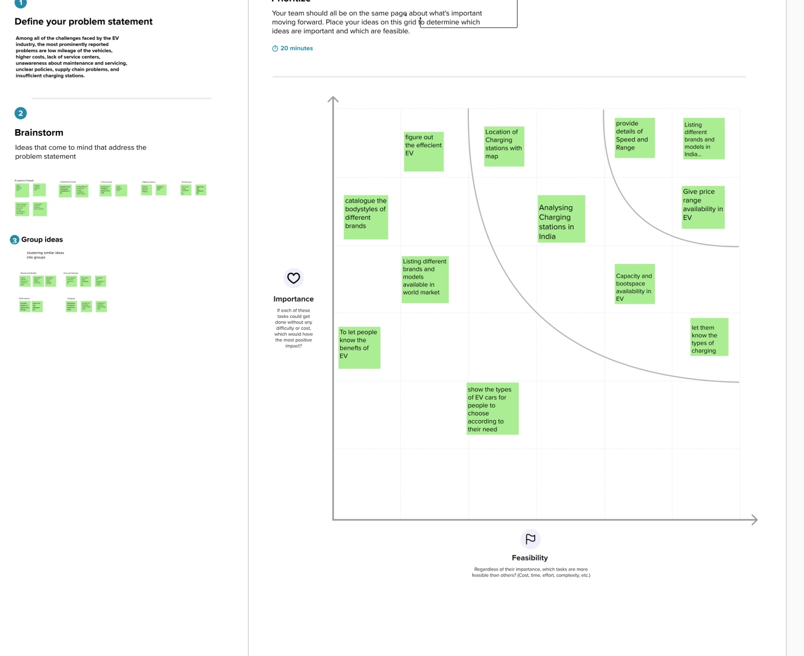

**2Results**

3.1-Data Collection & Extraction from Database

For this project the data was collected from This data gives us the idea about the sales of electric car in different regions of the world. The distribution is with respect to et name, year&region

Rank: Ranking of overall sales

Name: Name of the company

Year: wich year car lanch

NA_Sales: Sales in North America

EU_Sales: Sales in Europe

JP_Sales: Sales in Japan

Other_Sales: Sales in other countries

Global_Sales: Global Sales

3.2-Data Visualization

The number of unique visualizations that can be created with a given dataset. Some common types of visualizations that can be used to analyze the performance and efficiency of

Radisson Hotels include bar charts, line charts, heat maps, scatter plots, pie charts,Maps etc.

These visualizations can be used to compare performance, track changes over time, show

distribution, and relationships between variables, breakdown of revenue and customer

demographics, workload, resource allocation and location of sales of Games.

3.2.1-Sales in different region Analysis

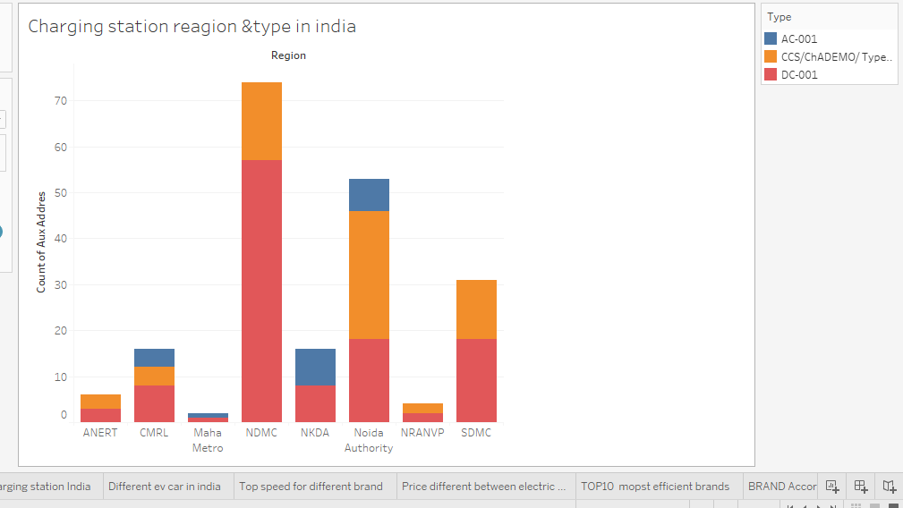

3.2.2

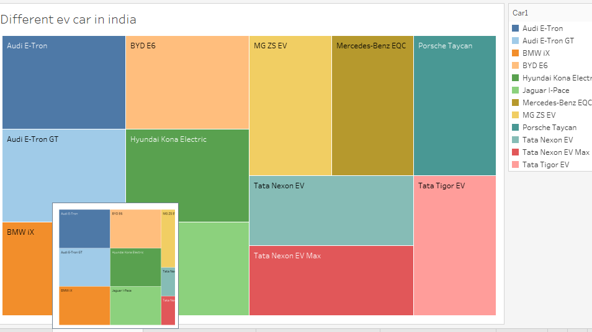

3.2.3

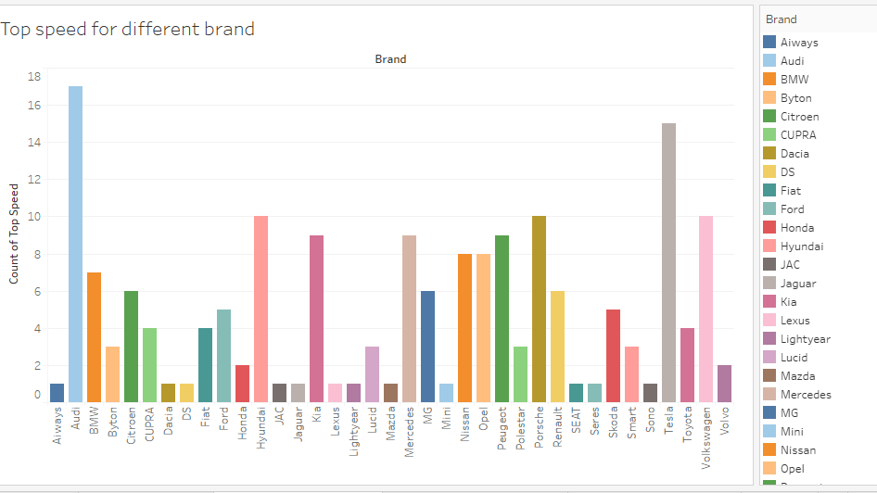

3.2.4

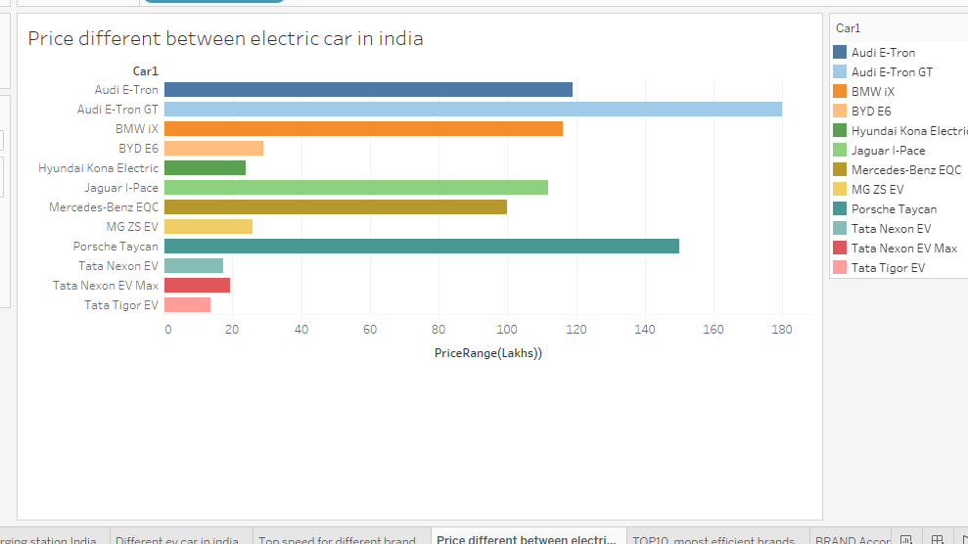

3.2.5

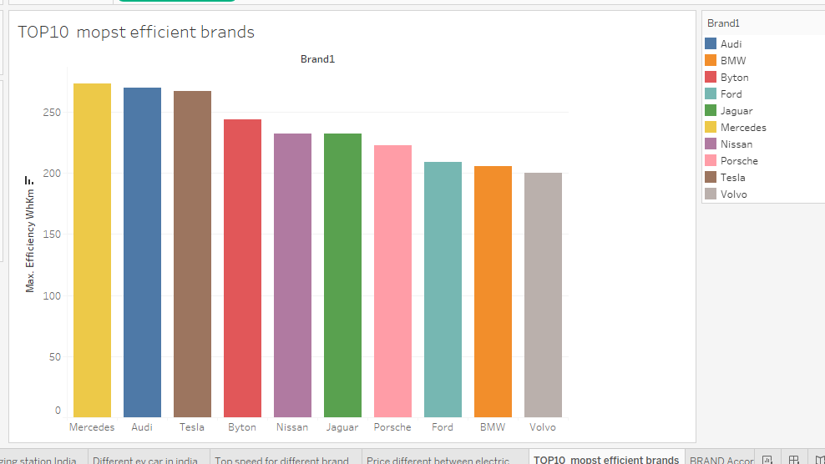

3.2.6

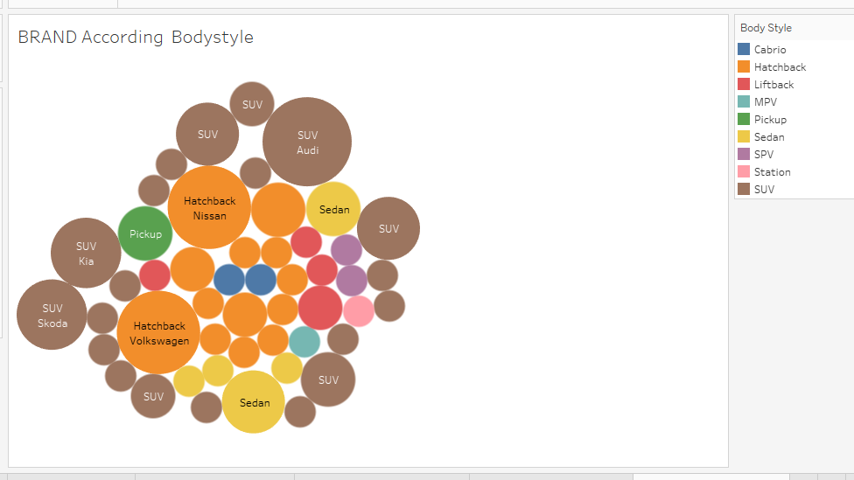

3.2.7

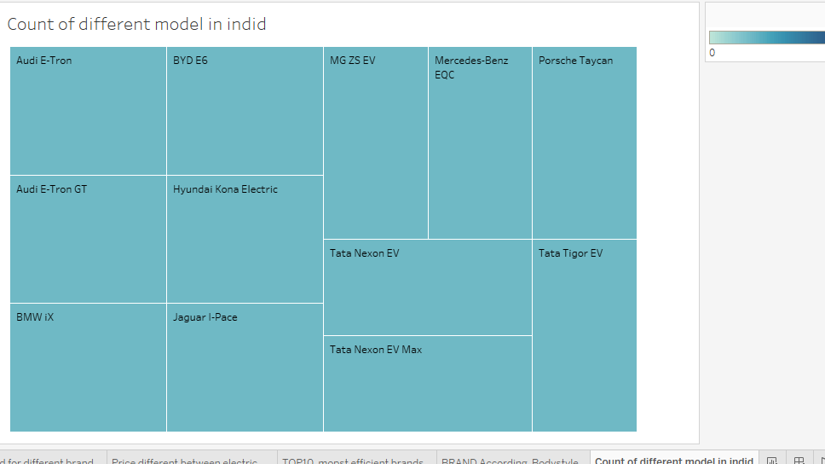

3.2.7

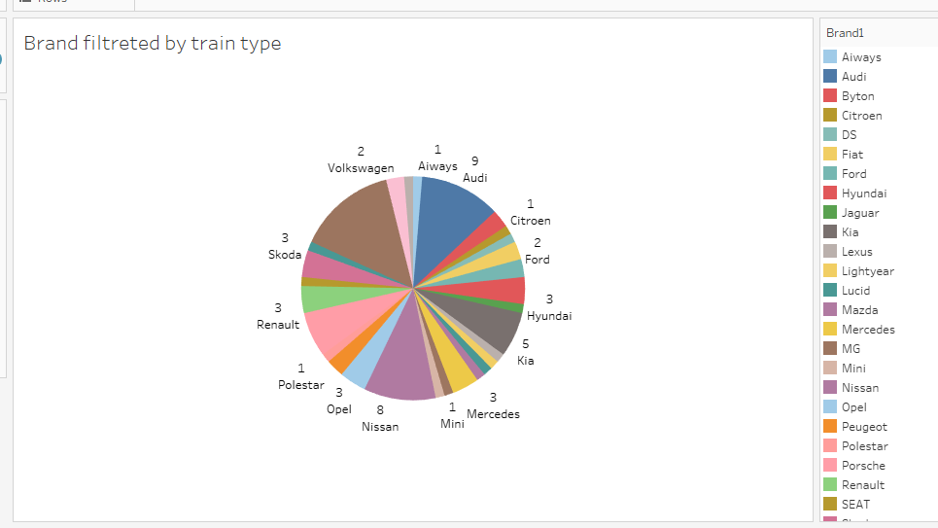

3.2.8



3.3-Dashboard

A dashboard is a graphical user interface (GUI) that displays information and data in an organized,

easy-to-read format. Dashboards are often used to provide real-time monitoring and analysis of data,

and are typically de signed for a specific purpose or use case. Dashboards can be used in a variety of

settings, such as business, finance, manufacturing, healthcare, and many other industries. They can

be used to track key performance indicators (KPIs), monitor performance metrics, and display data in

the form of charts, graphs, and tables.

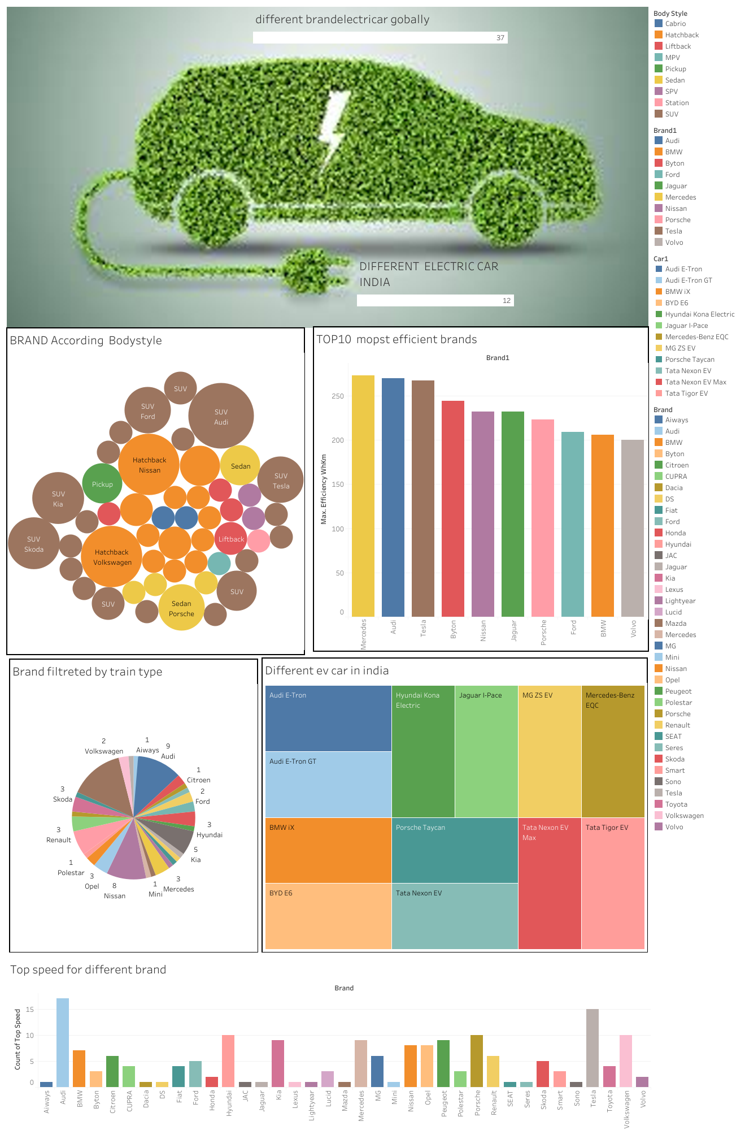

**3.4-Story**

A data story is a way of presenting data and analysis in a narrative format, with the goal of making the information more engaging and easier to understand. A data story typically includes a clearintroduction that sets the stage and explains the context for the data, a body that presents the dataand analysis in a logical and systematic way, and a conclusion that summarizes the key findings andhighlights their implications. Data stories can be told using a variety of mediums, such as reports,presentations, interactive visualizations, and videos.

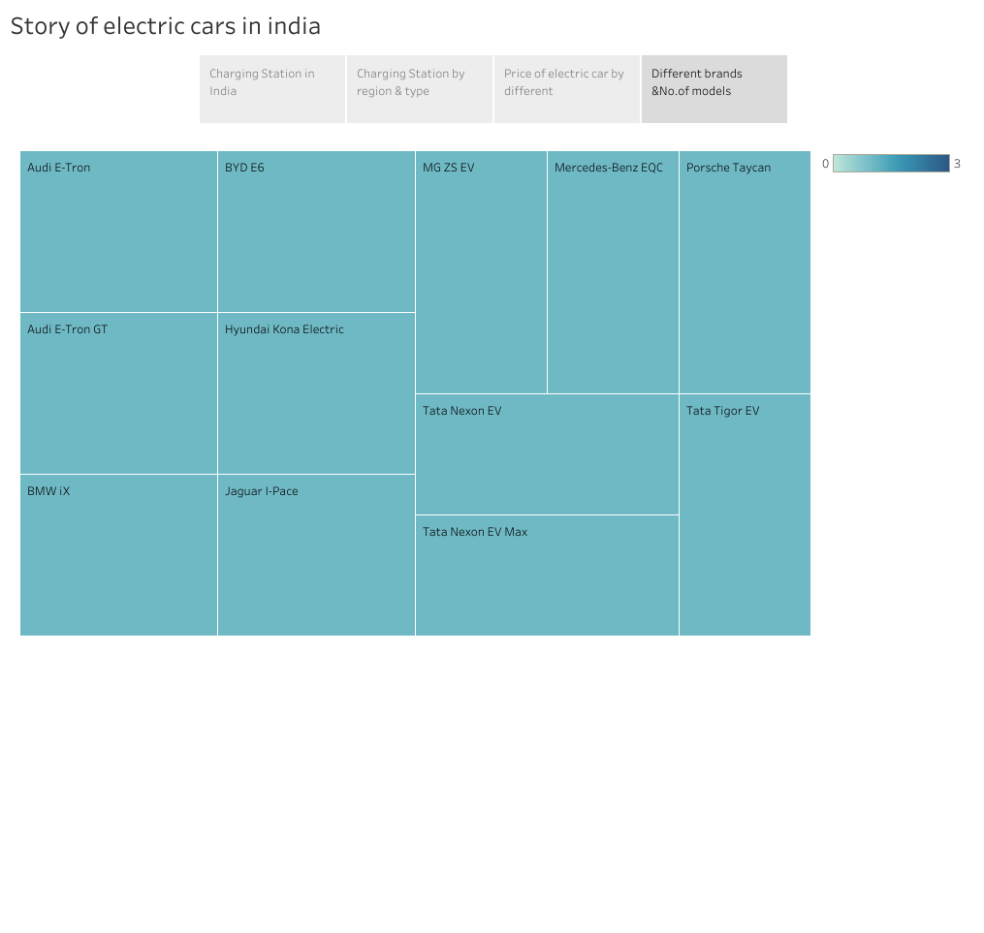

3.5-Web Integration

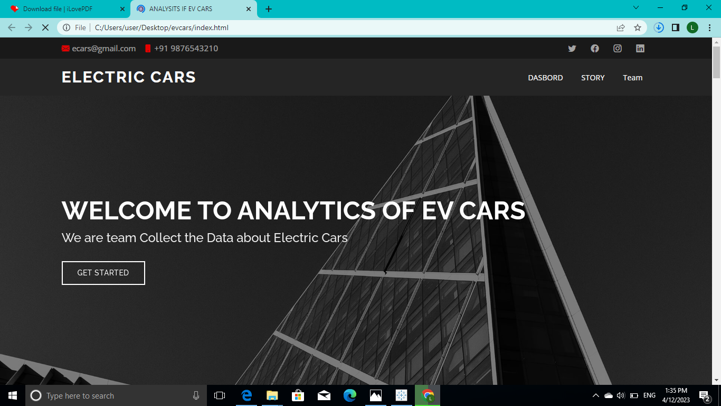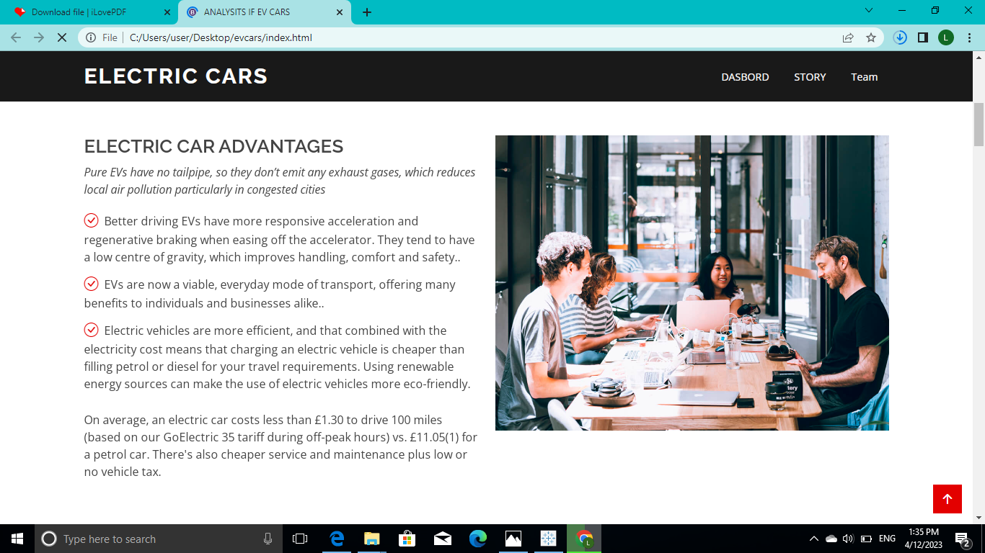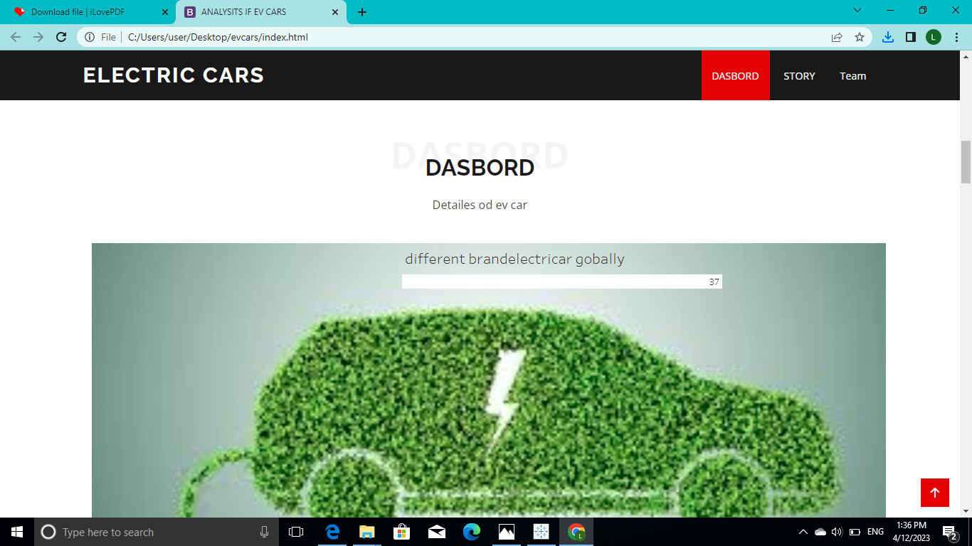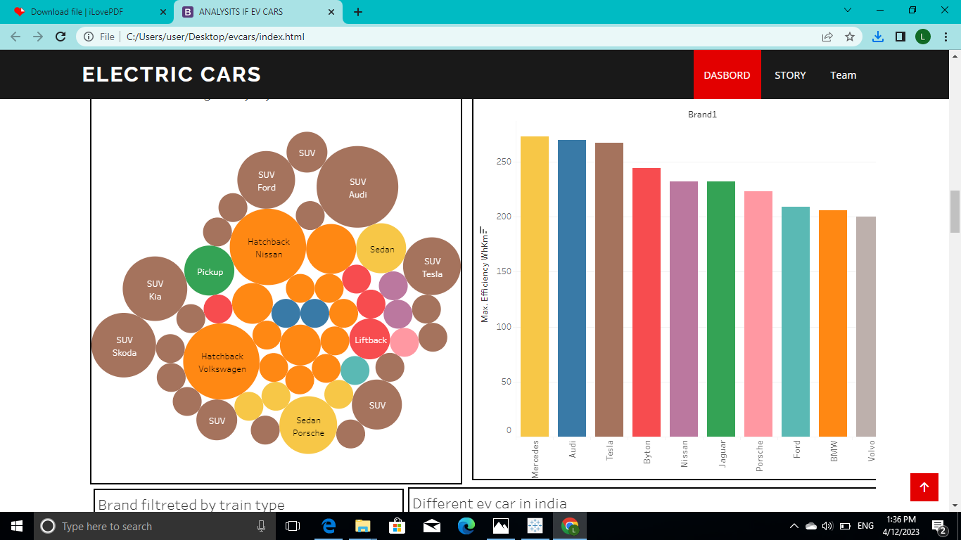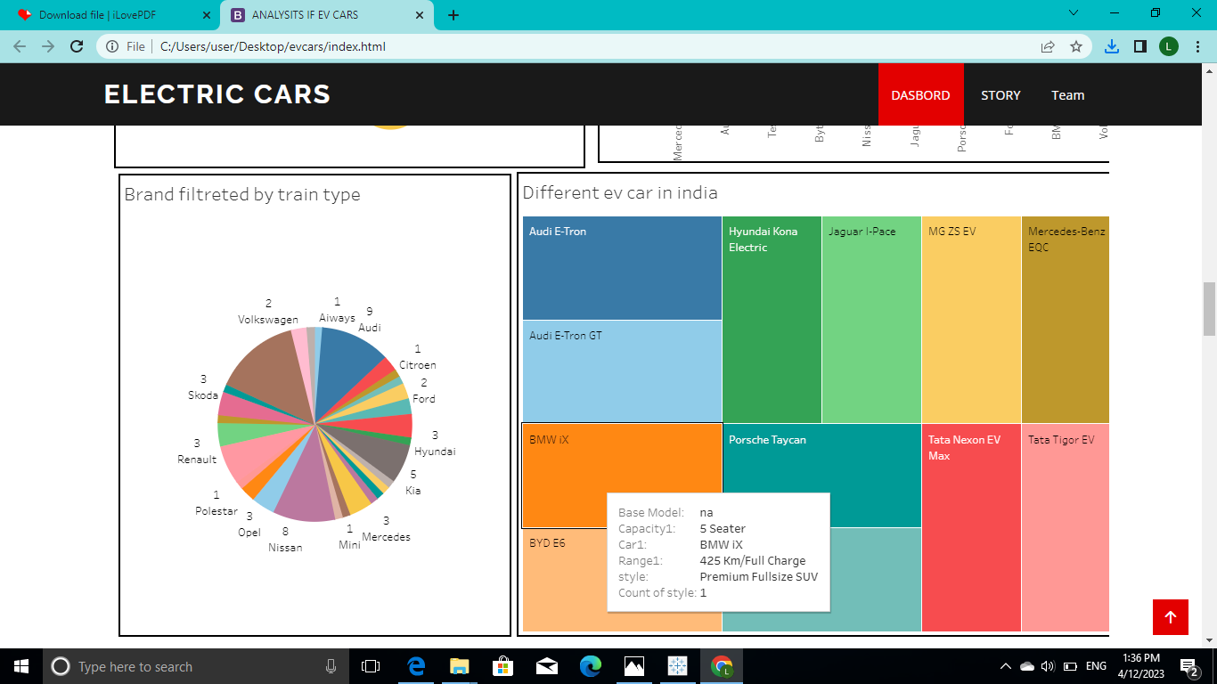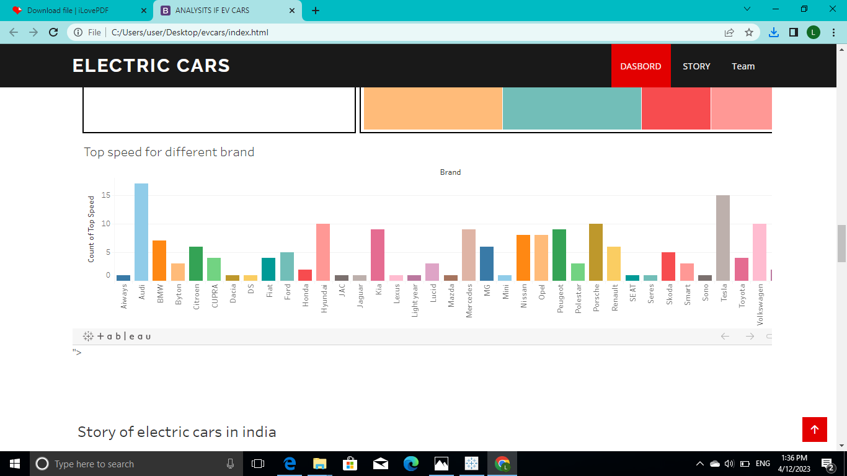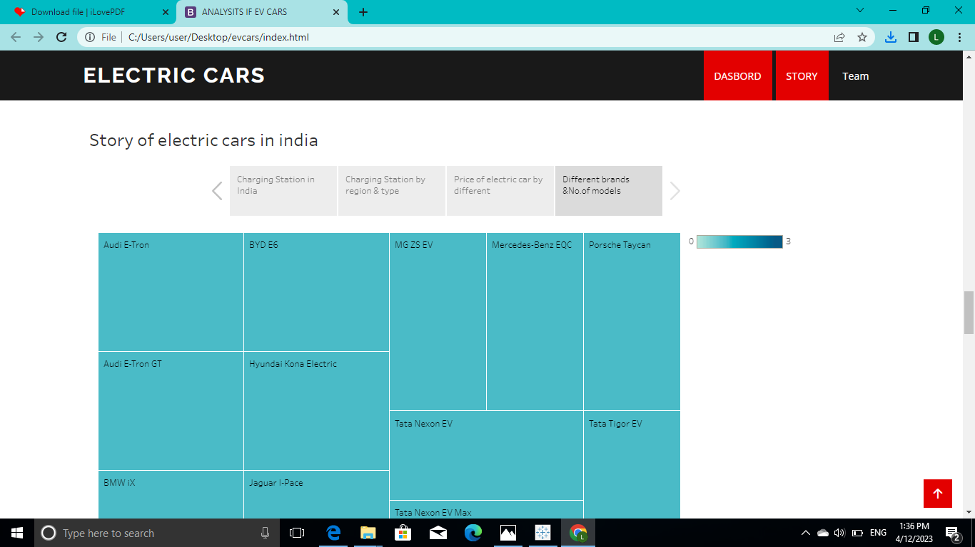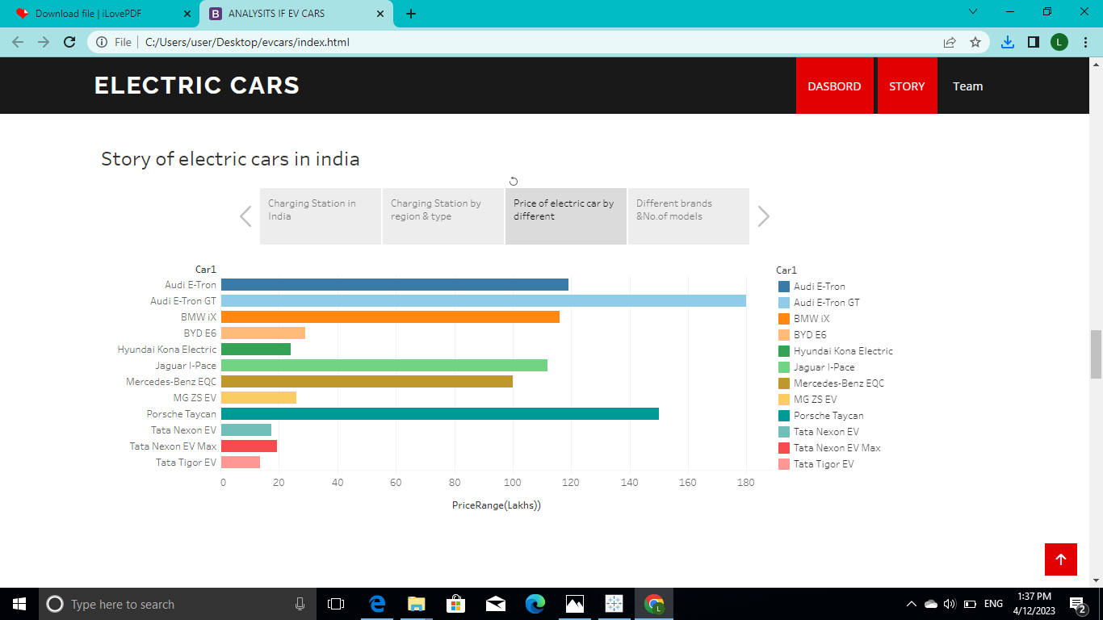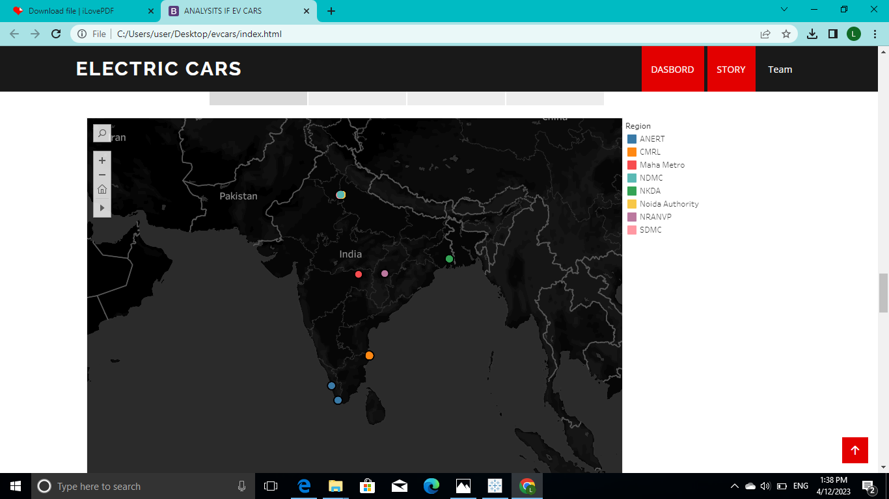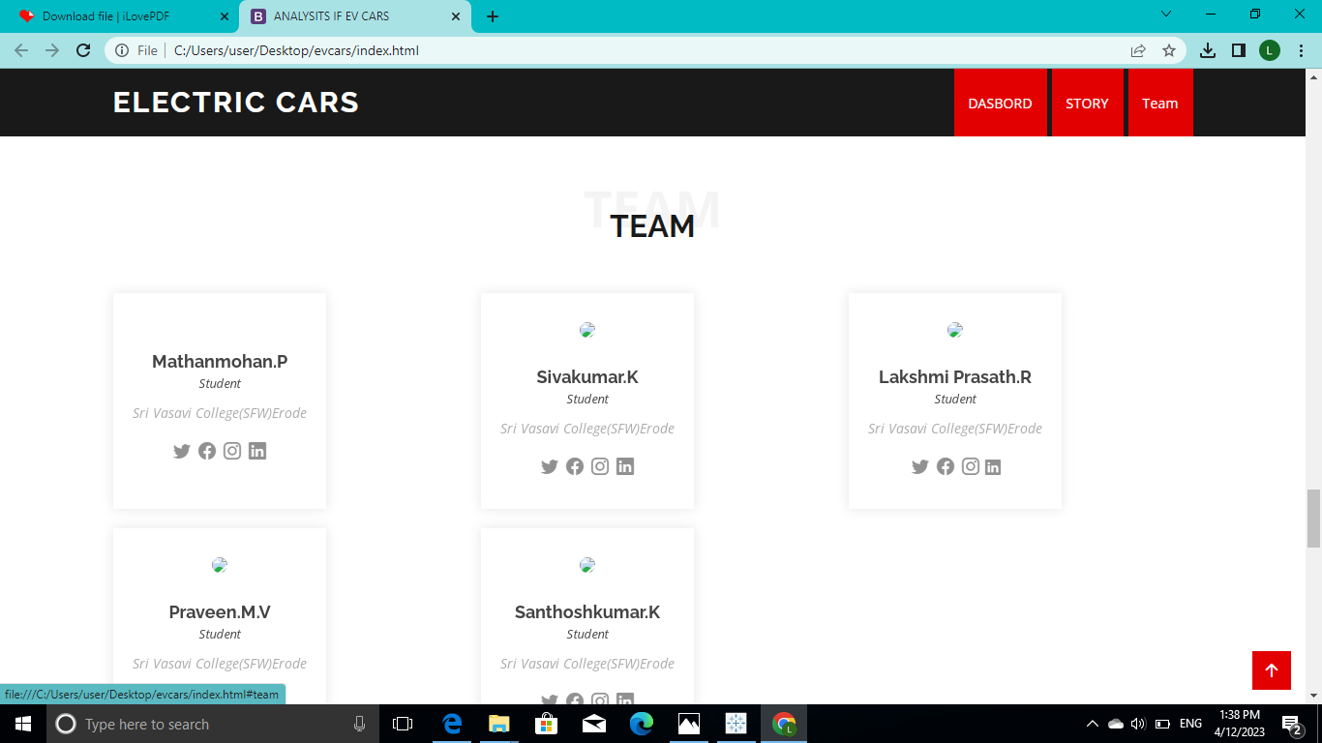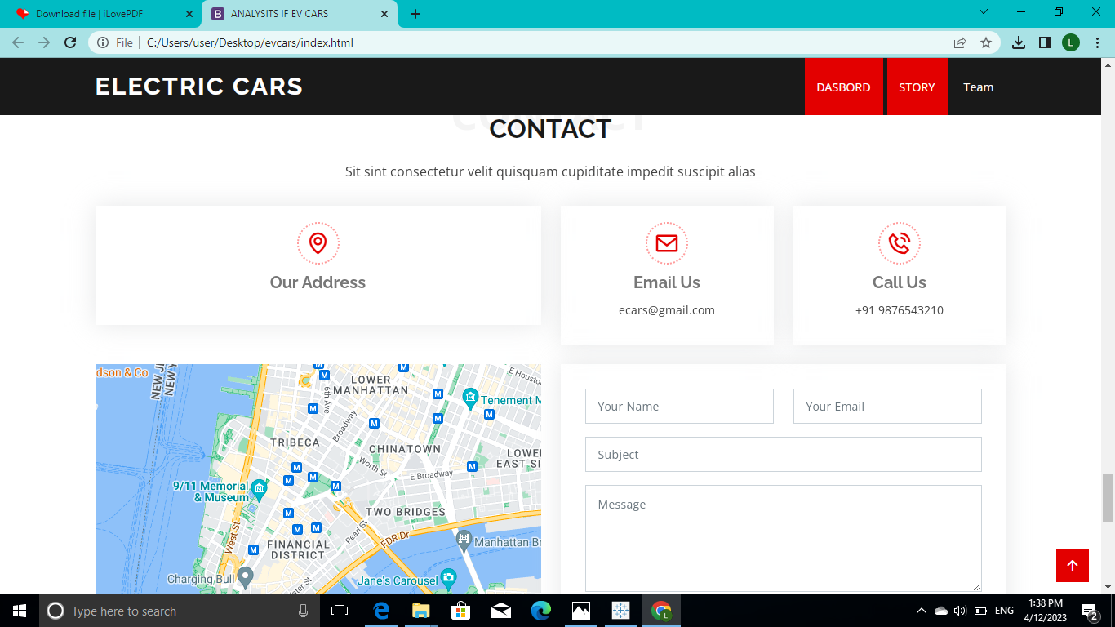

ADVANTAGES OF ELECTRIC VECHILE

**Eco-friendly:**Because electric vehicles do not utilize fuel for combustion, there are no emissions or gas exhaust. Vehicles that run on fossil fuels contribute significantly to hazardous gas accumulation in the environment, thus driving an electric car can help contribute to a cleaner environment.

**Renewable energy source:** Electric vehicles run on renewable power, whereas conventional automobiles function on the combustion of fossil fuels, which reduces the world’s fossil-fuel stocks.

**Less noise and smoother motion:** Driving an electric car is significantly smoother. Because they lack fast-moving elements, they are quieter and produce less noise.

**Cost-effective:** Electricity is far less expensive than fuels such as gasoline and diesel, which are subject to regular price increases. When solar electricity is utilized at home, battery recharging is cost-effective.

**Low maintenance:** Because electric cars have fewer moving components, wear and tear is reduced when compared to traditional auto parts. Repairs are also simpler and less expensive than combustion engines.

**Government support:** Governments throughout the world have granted tax breaks to encourage people to drive electric vehicles as part of a green program.

DISADVANTAGES OF ELECTRIC VECHILE

**High initial cost:**Electric vehicles continue to be quite expensive, and many buyers believe they are not as inexpensive as traditional automobiles.

**Charging station limitations:** People who need to travel long distances are concerned about finding adequate charging stations in the middle of their journey, which are not always accessible.

**Recharging takes time:** Unlike conventional automobiles, which require only a few minutes to replenish their gas tanks, charging an electric vehicle takes many hours.

**Limited options:**Currently, there aren’t many electric car models to pick from in terms of appearance, style, or customized variations.

**Less driving range:**When compared to conventional automobiles, electric vehicles have a shorter driving range. Electric cars can be convenient for short-distance travel but are inconvenient for long-distance travel.

**Conclusion**

The progress that the electric vehicle industry has seen in recent years is not only extremely welcomed, but highly necessary in light of the increasing global greenhouse gas levels. As demonstrated within the economic, social, and environmental analysis sections of this webpage, the benefits of electric vehicles far surpass the costs. The biggest obstacle to the widespread adoption of electric-powered transportation is cost related, as gasoline and the vehicles that run on it are readily available, convenient, and less costly. As is demonstrated in our timeline, we hope that over the course of the next decade technological advancements and policy changes will help ease the transition from traditional fuel-powered vehicles. Additionally, the realization and success of this industry relies heavily on the global population, and it is our hope that through mass marketing and environmental education programs people will feel incentivized and empowered to drive an electric-powered vehicle. Each person can make a difference, so go electric and help make a difference!

**APPENDIX**

<!DOCTYPE html>

<html lang="en">

<head>

<meta charset="utf-8">

<meta content="width=device-width, initial-scale=1.0" name="viewport">

<title>ANALYSITS IF EV CARS</title>

<meta content="" name="description">

<meta content="" name="keywords">

<!-- Favicons -->

<link href="assets/img/favicon.png" rel="icon">

<link href="assets/img/apple-touch-icon.png" rel="apple-touch-icon">

<!-- Google Fonts -->

<link href="https://fonts.googleapis.com/css?family=Open+Sans:300,300i,400,400i,600,600i,700,700i|Raleway:300,300i,400,400i,500,500i,600,600i,700,700i|Poppins:300,300i,400,400i,500,500i,600,600i,700,700i" rel="stylesheet">

<!-- Vendor CSS Files -->

<link href="assets/vendor/aos/aos.css" rel="stylesheet">

<link href="assets/vendor/bootstrap/css/bootstrap.min.css" rel="stylesheet">

<link href="assets/vendor/bootstrap-icons/bootstrap-icons.css" rel="stylesheet">

<link href="assets/vendor/boxicons/css/boxicons.min.css" rel="stylesheet">

<link href="assets/vendor/glightbox/css/glightbox.min.css" rel="stylesheet">

<link href="assets/vendor/swiper/swiper-bundle.min.css" rel="stylesheet">

<!-- Template Main CSS File -->

<link href="assets/css/style.css" rel="stylesheet">

<!-- =======================================================

* Template Name: EV Anaylist

* Updated: april 8 2023 with Bootstrap v5.2.3

* Template URL: https://bootstrapmade.com/ev cars-multipurpose-html-template-for-free/

* Author: BootstrapMade.com

* License: https://bootstrapmade.com/license/

======================================================== -->

</head>

<body>

<!-- ======= Top Bar ======= -->

<section id="topbar" class="d-flex align-items-center">

<div class="container d-flex justify-content-center justify-content-md-between">

<div class="contact-info d-flex align-items-center">

<i class="bi bi-envelope-fill"></i><a href="mailto:contact@example.com">ecars@gmail.com</a>

<i class="bi bi-phone-fill phone-icon"></i> +91 9876543210

</div>

<div class="social-links d-none d-md-block">

<a href="#" class="twitter"><i class="bi bi-twitter"></i></a>

<a href="#" class="facebook"><i class="bi bi-facebook"></i></a>

<a href="#" class="instagram"><i class="bi bi-instagram"></i></a>

<a href="#" class="linkedin"><i class="bi bi-linkedin"></i></i></a>

</div>

</div>

</section>

<!-- ======= Header ======= -->

<header id="header" class="d-flex align-items-center">

<div class="container d-flex align-items-center justify-content-between">

<h1 class="logo"><a href="index.html">Electric Cars</a></h1>

<!-- Uncomment below if you prefer to use an image logo -->

<!-- <a href="index.html" class="logo"><img src="assets/img/logo.png" alt="" class="img-fluid"></a>-->

<nav id="navbar" class="navbar">

<ul>

<li><a class="nav-link scrollto " href="#portfolio">DASBORD</a></li>

<li><a class="nav-link scrollto" href="#pricing">STORY</a></li>

<li><a class="nav-link scrollto" href="#team">Team</a></li>

</nav><!-- .navbar -->

</div>

</header><!-- End Header -->

<!-- ======= Hero Section ======= -->

<section id="hero" class="d-flex align-items-center">

<div class="container position-relative" data-aos="fade-up" data-aos-delay="500">

<h1>Welcome to Analytics of EV Cars</h1>

<h2>We are team Collect the Data about Electric Cars</h2>

<a href="#about" class="btn-get-started scrollto">Get Started</a>

</div>

</section><!-- End Hero -->

<main id="main">

<!-- ======= About Section ======= -->

<section id="about" class="about">

<div class="container">

<div class="row">

<div class="col-lg-6 order-1 order-lg-2" data-aos="fade-left">

<img src="assets/img/about.jpg" class="img-fluid" alt="">

</div>

<div class="col-lg-6 pt-4 pt-lg-0 order-2 order-lg-1 content" data-aos="fade-right">

<h3>ELECTRIC CAR ADVANTAGES</h3>

<p class="fst-italic">

Pure EVs have no tailpipe, so they don’t emit any exhaust gases, which reduces local air pollution particularly in congested cities

</p>

<ul>

<li><i class="bi bi-check-circle"></i> Better driving

EVs have more responsive acceleration and regenerative braking when easing off the accelerator.

They tend to have a low centre of gravity, which improves handling, comfort and safety..</li>

<li><i class="bi bi-check-circle"></i> EVs are now a viable, everyday mode of transport, offering many benefits to individuals and businesses alike..</li>

<li><i class="bi bi-check-circle"></i> Electric vehicles are more efficient, and that combined with the electricity cost means that charging an electric vehicle is cheaper than filling petrol or diesel for your travel requirements. Using renewable energy sources can make the use of electric vehicles more eco-friendly.</li>

</ul>

<p>

On average, an electric car costs less than £1.30 to drive 100 miles (based on our GoElectric 35 tariff during off-peak hours) vs. £11.05(1) for a petrol car.

There's also cheaper service and maintenance plus low or no vehicle tax.

</div>

</div>

</div>

</section><!-- End About Section -->

<!-- ======= Why Us Section ======= -->

<!-- ======= Portfolio Section ======= -->

<section id="portfolio" class="portfolio">

<div class="container">

<div class="section-title">

<span>Dasbord</span>

<h2>Dasbord</h2>

<p>Detailes od ev car</p>

</div>

<div class="row"

<div class='tableauPlaceholder' id='viz1680921733018' style='position: relative'><noscript><a href='#'><img alt='Dashboard 1 ' src='https:&#47;&#47;public.tableau.com&#47;static&#47;images&#47;Bo&#47;Book3_16809217017630&#47;Dashboard1&#47;1_rss.png' style='border: none' /></a></noscript><object class='tableauViz' style='display:none;'><param name='host_url' value='https%3A%2F%2Fpublic.tableau.com%2F' /> <param name='embed_code_version' value='3' /> <param name='site_root' value='' /><param name='name' value='Book3_16809217017630&#47;Dashboard1' /><param name='tabs' value='no' /><param name='toolbar' value='yes' /><param name='static_image' value='https:&#47;&#47;public.tableau.com&#47;static&#47;images&#47;Bo&#47;Book3_16809217017630&#47;Dashboard1&#47;1.png' /> <param name='animate_transition' value='yes' /><param name='display_static_image' value='yes' /><param name='display_spinner' value='yes' /><param name='display_overlay' value='yes' /><param name='display_count' value='yes' /><param name='language' value='en-US' /><param name='filter' value='publish=yes' /></object></div> <script type='text/javascript'> var divElement = document.getElementById('viz1680921733018'); var vizElement = divElement.getElementsByTagName('object')[0]; if ( divElement.offsetWidth > 800 ) { vizElement.style.width='1320px';vizElement.style.height='2027px';} else if ( divElement.offsetWidth > 500 ) { vizElement.style.width='1320px';vizElement.style.height='2027px';} else { vizElement.style.width='100%';vizElement.style.height='2477px';} var scriptElement = document.createElement('script'); scriptElement.src = 'https://public.tableau.com/javascripts/api/viz_v1.js'; vizElement.parentNode.insertBefore(scriptElement, vizElement); </script>">

</div>

<!-- ======= Pricing Section ======= -->

<section id="pricing" class="pricing">

<div class="container">

<div class="section-title">

<div class='tableauPlaceholder' id='viz1680922840476' style='position: relative'><noscript><a href='#'><img alt='Story of electric cars in india ' src='https:&#47;&#47;public.tableau.com&#47;static&#47;images&#47;Bo&#47;Book2_16808888550730&#47;Storyofelectriccarsinindia&#47;1_rss.png' style='border: none' /></a></noscript><object class='tableauViz' style='display:none;'><param name='host_url' value='https%3A%2F%2Fpublic.tableau.com%2F' /> <param name='embed_code_version' value='3' /> <param name='site_root' value='' /><param name='name' value='Book2_16808888550730&#47;Storyofelectriccarsinindia' /><param name='tabs' value='no' /><param name='toolbar' value='yes' /><param name='static_image' value='https:&#47;&#47;public.tableau.com&#47;static&#47;images&#47;Bo&#47;Book2_16808888550730&#47;Storyofelectriccarsinindia&#47;1.png' /> <param name='animate_transition' value='yes' /><param name='display_static_image' value='yes' /><param name='display_spinner' value='yes' /><param name='display_overlay' value='yes' /><param name='display_count' value='yes' /><param name='language' value='en-US' /></object></div> <script type='text/javascript'> var divElement = document.getElementById('viz1680922840476'); var vizElement = divElement.getElementsByTagName('object')[0]; vizElement.style.width='1016px';vizElement.style.height='991px'; var scriptElement = document.createElement('script'); scriptElement.src = 'https://public.tableau.com/javascripts/api/viz_v1.js'; vizElement.parentNode.insertBefore(scriptElement, vizElement); </script>

</div>

</div>

</div>

<!-- ======= Team Section ======= -->

<section id="team" class="team">

<div class="container">

<div class="section-title">

<span>Team</span>

<h2>Team</h2>

<p></p>

</div>

<div class="row">

<div class="col-lg-4 col-md-6 d-flex align-items-stretch" data-aos="zoom-in">

<div class="member">

<img src="" alt="">

<h4>Mathanmohan.P</h4>

<span>Student</span>

<p>

Sri Vasavi College(SFW)Erode

</p>

<div class="social">

<a href=""><i class="bi bi-twitter"></i></a>

<a href=""><i class="bi bi-facebook"></i></a>

<a href=""><i class="bi bi-instagram"></i></a>

<a href=""><i class="bi bi-linkedin"></i></a>

</div>

</div>

</div>

<div class="col-lg-4 col-md-6 d-flex align-items-stretch" data-aos="zoom-in">

<div class="member">

<img src="C:\Users\user\Pictures\Camera Roll\_0(image0)alia2.jpg">

<h4>Sivakumar.K</h4>

<span>Student</span>

<p>

Sri Vasavi College(SFW)Erode

</p>

<div class="social">

<a href=""><i class="bi bi-twitter"></i></a>

<a href=""><i class="bi bi-facebook"></i></a>

<a href=""><i class="bi bi-instagram"></i></a>

<a href=""><i class="bi bi-linkedin"></i></a>

</div>

</div>

</div>

<div class="col-lg-4 col-md-6 d-flex align-items-stretch" data-aos="zoom-in">

<div class="member">

<img src=" alt="">

<h4>Lakshmi Prasath.R</h4>

<span>Student</span>

<p>

Sri Vasavi College(SFW)Erode

</p>

<div class="social">

<a href=""><i class="bi bi-twitter"></i></a>

<a href=""><i class="bi bi-facebook"></i></a>

<a href=""><i class="bi bi-instagram"></i></a>

<a href=""><is class="bi bi-linkedin"></i></a>

</div>

</div>

</div>

<div class="col-lg-4 col-md-6 d-flex align-items-stretch" data-aos="zoom-in">

<div class="member">

<img src=" alt="">

<h4>Praveen.M.V</h4>

<span>Student</span>

<p>

Sri Vasavi College(SFW)Erode

</p>

<div class="social">

<a href=""><i class="bi bi-twitter"></i></a>

<a href=""><i class="bi bi-facebook"></i></a>

<a href=""><i class="bi bi-instagram"></i></a>

<a href=""><is class="bi bi-linkedin"></i></a>

</div>

</div>

</div>

<div class="col-lg-4 col-md-6 d-flex align-items-stretch" data-aos="zoom-in">

<div class="member">

<img src="="">

<h4>Santhoshkumar.K</h4>

<span>Student</span>

<p>

Sri Vasavi College(SFW)Erode

</p>

<div class="social">

<a href=""><i class="bi bi-twitter"></i></a>

<a href=""><i class="bi bi-facebook"></i></a>

<a href=""><i class="bi bi-instagram"></i></a>

<a href=""><i class="bi bi-linkedin"></i></a>

</div>

</div>

</div>

</section><!-- End Team Section -->

<!-- ======= Contact Section ======= -->

<section id="contact" class="contact">

<div class="container">

<div class="section-title">

<span>Contact</span>

<h2>Contact</h2>

<p>Sit sint consectetur velit quisquam cupiditate impedit suscipit alias</p>

</div>

<div class="row" data-aos="fade-up">

<div class="col-lg-6">

<div class="info-box mb-4">

<i class="bx bx-map"></i>

<h3>Our Address</h3>

<p></p>

</div>

</div>

<div class="col-lg-3 col-md-6">

<div class="info-box mb-4">

<i class="bx bx-envelope"></i>

<h3>Email Us</h3>

<p>ecars@gmail.com</p>

</div>

</div>

<div class="col-lg-3 col-md-6">

<div class="info-box mb-4">

<i class="bx bx-phone-call"></i>

<h3>Call Us</h3>

<p>+91 9876543210</p>

</div>

</div>

</div>

<div class="row" data-aos="fade-up">

<div class="col-lg-6 ">

<iframe class="mb-4 mb-lg-0" src="https://www.google.com/maps/embed?pb=!1m14!1m8!1m3!1d12097.433213460943!2d-74.0062269!3d40.7101282!3m2!1i1024!2i768!4f13.1!3m3!1m2!1s0x0%3A0xb89d1fe6bc499443!2sDowntown+Conference+Center!5e0!3m2!1smk!2sbg!4v1539943755621" frameborder="0" style="border:0; width: 100%; height: 384px;" allowfullscreen></iframe>

</div>

<div class="col-lg-6">

<form action="forms/contact.php" method="post" role="form" class="php-email-form">

<div class="row">

<div class="col-md-6 form-group">

<input type="text" name="name" class="form-control" id="name" placeholder="Your Name" required>

</div>

<div class="col-md-6 form-group mt-3 mt-md-0">

<input type="email" class="form-control" name="email" id="email" placeholder="Your Email" required>

</div>

</div>

<div class="form-group mt-3">

<input type="text" class="form-control" name="subject" id="subject" placeholder="Subject" required>

</div>

<div class="form-group mt-3">

<textarea class="form-control" name="message" rows="5" placeholder="Message" required></textarea>

</div>

<div class="my-3">

<div class="loading">Loading</div>

<div class="error-message"></div>

<div class="sent-message">Your message has been sent. Thank you!</div>

</div>

<div class="text-center"><button type="submit">Send Message</button></div>

</form>

</div>

</div>

</div>

</section><!-- End Contact Section -->

</main><!-- End #main -->

<!-- ======= Footer ======= -->

<footer id="footer">

<div class="footer-top">

<div class="container">

<div class="row">

<div class="col-lg-4 col-md-6">

<div class="footer-info">

<h3>EV CARS</h3>

<p>

A<br><br>

<strong>Phone:</strong> +91 8637482570<br>

<strong>Email:</strong> evcars@gmail.com<br>

</p>

<div class="social-links mt-3">

<a href="#" class="twitter"><i class="bx bxl-twitter"></i></a>

<a href="#" class="facebook"><i class="bx bxl-facebook"></i></a>

<a href="#" class="instagram"><i class="bx bxl-instagram"></i></a>

<a href="#" class="google-plus"><i class="bx bxl-skype"></i></a>

<a href="#" class="linkedin"><i class="bx bxl-linkedin"></i></a>

</div>

</div>

</div>

<div class="col-lg-2 col-md-6 footer-links">

<h4>THANK YOU</h4>

<ul>

<li><i class="bx bx-chevron-right"></i> <a href="#">Home</a></li>

<li><i class="bx bx-chevron-right"></i> <a href="#">About us</a></li>

<li><i class="bx bx-chevron-right"></i> <a href="#">Services</a></li>

<li><i class="bx bx-chevron-right"></i> <a href="#">Terms of service</a></li>

<li><i class="bx bx-chevron-right"></i> <a href="#">Privacy policy</a></li>

</ul>

</div>

<div class="col-lg-2 col-md-6 footer-links">

<h4>Our Services</h4>

<ul>

<li><i class="bx bx-chevron-right"></i> <a href="#">Web Design</a></li>

<li><i class="bx bx-chevron-right"></i> <a href="#">Web Development</a></li>

<li><i class="bx bx-chevron-right"></i> <a href="#">Product Management</a></li>

<li><i class="bx bx-chevron-right"></i> <a href="#">Marketing</a></li>

<li><i class="bx bx-chevron-right"></i> <a href="#">Graphic Design</a></li>

</ul>

</div>

<div class="col-lg-4 col-md-6 footer-newsletter">

<h4>Our Newsletter</h4>

<p>Tamen quem nulla quae legam multos aute sint culpa legam noster magna</p>

<form action="" method="post">

<input type="email" name="email"><input type="submit" value="Subscribe">

</form>

</div>

</div>

</div>

</div>

<div class="container">

<div class="copyright">

&copy; Copyright <strong><span>Day</span></strong>. All Rights Reserved

</div>

<div class="credits">

<!-- All the links in the footer should remain intact. -->

<!-- You can delete the links only if you purchased the pro version. -->

</html> <!-- Licensing information: https://bootstrapmade.com/license/ -->

<!-- Purchase the pro version with working PHP/AJAX contact form: https://bootstrapmade.com/day-multipurpose-html-template-for-free/ -->

Designed by <a href="https://bootstrapmade.com/">BootstrapMade</a>

</div>

</div>

</footer><!-- End Footer -->

<a href="#" class="back-to-top d-flex align-items-center justify-content-center"><i class="bi bi-arrow-up-short"></i></a>

<div id="preloader"></div>

<!-- Vendor JS Files -->

<script src="assets/vendor/aos/aos.js"></script>

<script src="assets/vendor/bootstrap/js/bootstrap.bundle.min.js"></script>

<script src="assets/vendor/glightbox/js/glightbox.min.js"></script>

<script src="assets/vendor/isotope-layout/isotope.pkgd.min.js"></script>

<script src="assets/vendor/swiper/swiper-bundle.min.js"></script>

<script src="assets/vendor/php-email-form/validate.js"></script>

<!-- Template Main JS File -->

<script src="assets/js/main.js"></script>

</body>